[Caribbean Sea](https://www.google.com/search?safe=active&sca_esv=563733001&cs=0&q=Caribbean+Sea&stick=H4sIAAAAAAAAAEVSv2_TQBj1RUpwHColbocoUxQJKYqQYruxHTPQSGWtImgRbJHjH4lj3zn2WbWdkb8AMTAjBsTAX8CAKjYygGBATAzdGFDXIiFBEu4zNz29e-9933338eUO38d9SdHkQ6VOHbPtkXYyd9ppGAf2GhWXDA5omjEoSykIFgkeAqsqSgHnOoPawgWtjAN_jaq73Hilxox2M19ntJxIusRo25VkBmeHxALFkGLCaNWIUqB9IlGoqMmrImPgMjgnhrFGwi5OHZDDOeMtNd5Uv7GFywk80JL8olN7YZ1DlYAQGIcexwZIMmpThtXVuYtZnq9EoJjlNACc6lnRtupio3iCtoQUxZps577rVol0VS-CcilawocYMeSohGYThjXNCiSQD0nRmZJFS_t_jDWAKU4XLlgz6mMYkjtzMZSVcT5MwEtiKWFe36YwJ1kZyirzqomUr2AX_Ml8eokuUa3-4_r7fusbevbmw1f0GQnVR9tFSz3bEcdC7dRJzsKT0PbcXByJd4XqiYOnTkzHrtgRhOMwCBwr8UIiHrREod63CqK_WV3a2Xvw7-_JMrtApY6vPHz75fnHyrjBbc7jyv1Rq9trCJV7ITY90vhZ57hXf66OevsCf2ZmIQlx3rj-VHph_Lo66jS3ptHv8q1Rs9bmupy8zYhuNy963Cb7ybvX7ys1HtU5pcxzIirdKXXRqsRzN1-W947N2JtOHZO0Tx3zaQX9BVFzIZVlAwAA&sa=X&ved=2ahUKEwjY6e_um5uBAxV2cmwGHaolA2YQ7fAIegUIABCiBQ)

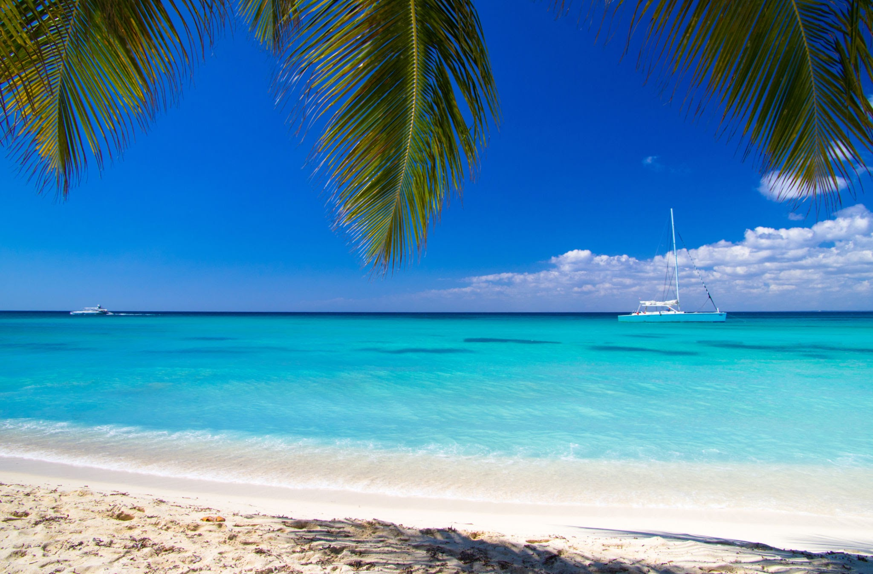

caribbeansea.png

The Caribbean Sea is a vast body of water located in the western part of the Atlantic Ocean, nestled between the Caribbean islands and the eastern coast of Central America and South America. It spans approximately 1,063,000 square miles (2,754,000 square kilometers) and is renowned for its stunning turquoise waters and warm, tropical climate. The sea is home to a diverse array of marine life, including colorful coral reefs, vibrant fish species, and endangered sea turtles. It plays a vital role in the region's economy, supporting tourism, fisheries, and trade. The Caribbean Sea's cultural significance is also reflected in the rich history of the Caribbean islands that surround it.

Example of marine life

1. Reef fish

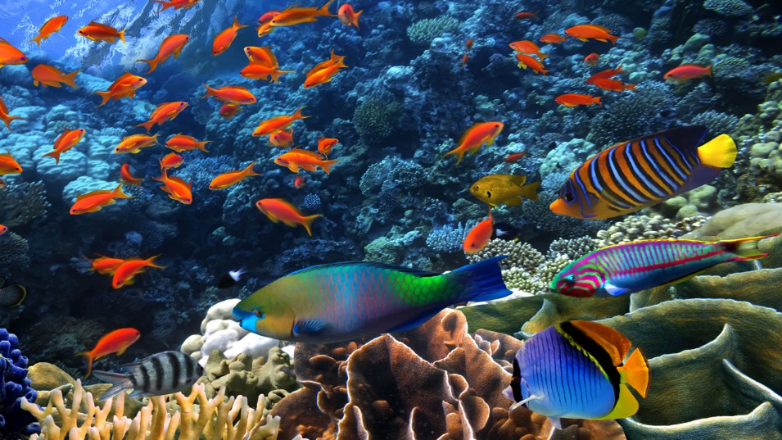

reeffish_creaturesincaribbean.png

1. Manatees

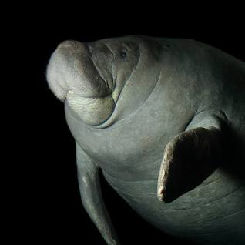

manatees_creaturesincaribbean.png